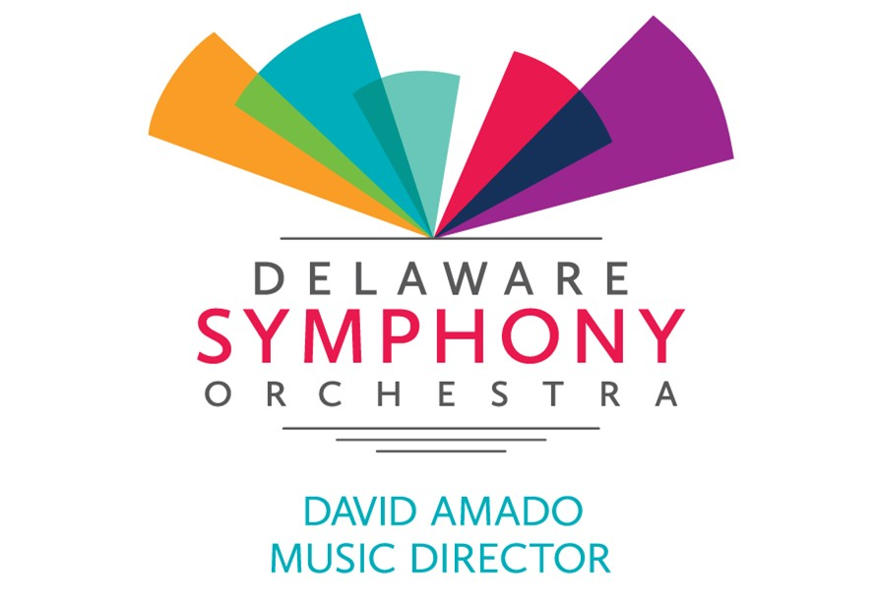
Development Committee Report

2018 – 2019 Annual Fund Raised to Date: | $999,852  895462.82
Raised Since Last Board Meeting: | $49,531
Left to Goal: | $152,034

Activity & Progress Highlights:
- Board Leadership Giving: As of May 17, thirteen Board members have made extra gifts totaling $15,032 toward our $20,000 Board Challenge goal, leaving $4,968 still to be raised from the remaining members by June 30 (but preferably much sooner).
- Individual Gift Solicitations Team: Charlie and Lanny continue to solicit chair sponsorship prospects, while Jeff, Matt, Patricia, and Bob call on other individual prospects and Debbie keeps track of progress on a weekly spreadsheet. A Sponsorship and Underwriting Opportunities brochure by RSC, Bob, and the staff offers sponsorship opportunities at various levels for musician chairs and classical and chamber concerts, plus new opportunities to underwrite Explorer Concerts from one share ($500) up to eight shares ($4,000).
- Corporate Solicitations Team: Jimi, Dave, and Alan are using the Sponsorship Opportunities brochure as they continue to seek out and call on corporate prospects.
- Stewardship Team: The May 17 concert saw a flurry of cultivation activities including a President’s Reception for major donors in the Ninth Muse during intermission and simultaneous before- and after-concert receptions for chair sponsors and musicians in the Sarah Bernhardt Salon and for subscribers and musicians in the baby grand lobby. Tatiana and Gerret Copeland were honored on stage and WPC Chief Robert Tracy and his wife were guests of the President. Bob brought eleven neighbors to the concert, five of whom were new to the DSO. The TY note writing committee will start after June 30.
- Robert Swaney Consultants :
  - Bob, Cat and Kristin have drafted a year-end mailing based on the 60-Day value-based message and the new sponsorship and underwriters brochure.
  - After brainstorming with Charlie, Bob and staff regarding DSO facts, feeling and finances, they are writing a new two-page case statement based on our audiences, educational outreach, and service to the region.
  - New reporting protocols are now tracking progress and being analyzed.
- Respectfully submitted: Bob Stoddard, Chair

100 West 10th Street, Suite 1003 Wilmington, DE 19810 | 302-656-7442 | www.delawaresymphony.org

